Installing Standalone Seagate Crystal Reports

Overview
This document provides information and instructions on how to install Seagate Crystal Reports 8.
Contents
Installation Requirements 2
Installing Seagate Crystal Reports 2
To install on a local machine 2
Customizing your installation: 3
Installing from a network: 4
Installing Seagate Crystal Reports to the network 5
What you should do before users install from the network 6

Installation Requirements

Seagate Crystal Reports 8 has the following installation requirements:
- Microsoft Windows 95, Windows 98, Windows NT 4.0, or higher
- Minimum RAM: 16 MB (32 MB for Windows NT)
- Recommended RAM: 32 MB
- Minimum hard drive space required: 30 MB
- Maximum hard drive space required (Full Install): 210 MB

Note that systems that do not meet these requirements may not run correctly.

Installing Seagate Crystal Reports

Users installing Seagate Crystal Reports from a network should read the section ‘Installing from a network’.

Users who need to limit the features installed should read the section ‘Customizing your installation’.

To install on a local machine

Note: Users installing to Windows NT or Windows 2000 need to be logged on as an Administrator.

- Double-click setup.exe.
Note: Depending on the existing system configuration, some users may be prompted to update existing files. If this occurs, click Yes and restart the machine. The installation expert updates the required files.

- In the ‘User Information’ dialog box, enter your name and CD Key Code.
Tip: The CD Key Code is printed on the sticker on the back of the CD envelope.

- Click Next. The ‘Select Installation Type’ box appears:

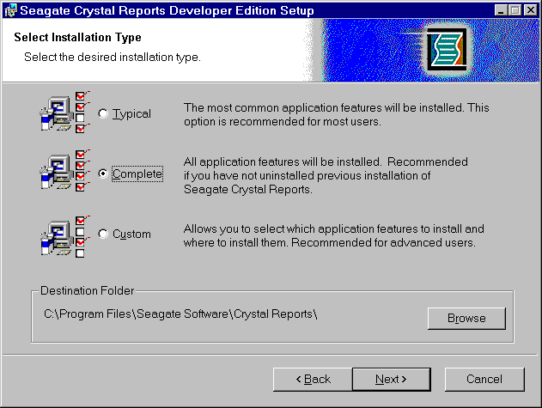
- Choose the installation type.

- Typical installs the most common application features.

- Complete installs all application features and subcomponents.

- Custom makes it possible for users to specify the features to be installed.
Choose Custom to check the amount of disk space each feature requires, install specific features, or change the default location of various features.
Users selecting the Custom option should read the following section Customizing your installation.

- Click Browse to specify the destination folder for the Seagate Crystal Reports install.
Note: The default is c:\Program Files\Seagate Software\Crystal Reports

- Click Next and follow the instructions in each dialog box to complete the install.

Customizing your installation:

Use the custom installation to check the amount of space (disk cost) each feature requires, install specific features, or change the default location of various features.

To customize your installation:

- Double-click Setup.
Note: Depending on the configuration of your current system, you may receive a dialog box informing you to update existing files. Click Yes and restart your machine. The install expert updates the required files.
Tip: The CD Key Code is printed on the sticker on the back of the CD envelope.

- In the User Information dialog box, enter your name and CD Key Code.

- Click Next.

- In the Select Installation Type dialog box, select Custom for the installation type.

- Click Browse to choose the destination folder where you want Seagate Crystal Reports to be installed.

Note: The default is C:\Program Files\Seagate Software\Crystal Reports

- Click Next.
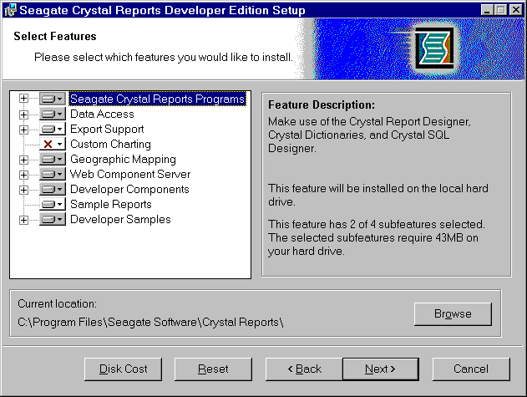
The Select Features window appears with a list of Seagate Crystal Report features:

- Click the driver icon of the features(s) you want to install.

- Select the configuration and location of the feature.

Type of feature installation | Description of what is installed
Will be installed on local hard drive | - feature only  - installed on hard drive
Entire feature will be installed on local hard drive | - feature  - subcomponents of feature  - installed on hard drive
Will be installed to run from network | - feature only  - installed to run from the network
Entire feature will be installed to run from network | - feature  - subcomponents of feature  - installed to run from the network
Entire feature will be unavailable | - feature and subcomponents not installed

Note: Subcomponents are listed below each feature. Subcomponents can have a different type of installation than their feature.

- Click Next and follow the instructions in each dialog box to complete the install.

Installing from a network:

If your network administrator has installed Seagate Crystal Reports over the network, make sure you have ‘read’ privileges to that network before beginning this process.

To install from a network:

- Access the network that contains the Seagate Crystal Reports installation files.

- Double-click setup.exe.
- or -
If you have the Microsoft Windows Installer on your machine, double-click scr.msi.
Note: Depending on your network administrator’s actions, you may or may not see the setup.exe, setup.ini, or instmsi(w).exe files. Contact your network administrator if you do not see the files.

- Depending on the configuration of your current system, you may receive a dialog box informing you to update existing files. Click Yes and restart your machine. The installation expert updates the required files.

- In the User Information dialog box, enter your name and CD Key Code.

- Click Next. The ‘Select Installation Type’ dialog box appears:

- Choose the installation type:

- Typical installs the most common application features.

- Complete installs all application features and subcomponents.

- Custom enables you to choose what features you want installed and where they will be installed.
Choose Custom if you want to check the amount of space (disk cost) each feature requires, install specific features, or change the default location of various features. If you select the custom option, see the section ‘Customizing your installation’.
Note: If you want a feature to be installed to run from the network, choose the custom install.

- Click Browse to choose the destination folder where you want Seagate Crystal Reports to be installed.

Note: The default is c:\Program Files\Seagate Software\Crystal Reports.

- Click Next and follow the instructions in each dialog box to complete the install.

Installing Seagate Crystal Reports to the network

This procedure should only be completed by a network administrator who has write access and network privileges.
Use this procedure to install Seagate Crystal Reports onto your network. When this procedure is complete, end users will be able to access the setup.exe or the scr.mis file from the network to install Seagate Crystal Reports onto their local machine.

Note: If users who do not have the Microsoft Windows Installer will need to copy setup files from the product CD to the network. See the section ‘What you should do before users install from the network’ after completing this procedure.

To install Seagate Crystal Reports to the network:

- Initialize the administrator’s installation by running the setup.exe with an additional command line switch. For example:
<path> setup.exe /a
Note: The <path> is the location of the Seagate Crystal Reports setup.
The ‘Admin Installation’ dialog box appears:
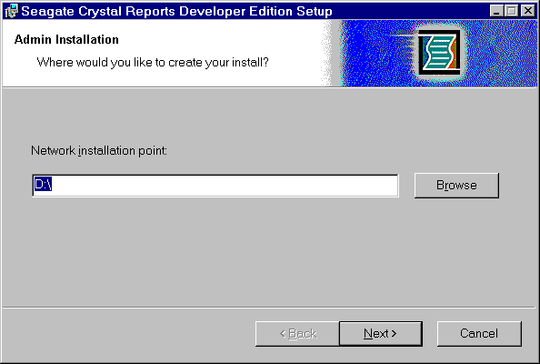

- In the ‘Admin Installation’ dialog box, click Browse to choose the network location where you want the Seagate Crystal Reports files to be located.

- Click Next.

- In the ‘Admin Installation Verify Ready’ dialog box, click OK to begin copying the files to the network.

What you should do before users install from the network

When the files are finished copying to the network, users who have the Microsoft Windows Installer can double-click the scr.mis file to begin the install.
If users do not have the Microsoft Windows Installer configured on their machine, copy the following files from the CD to the network:

For Windows 9x | For Windows NT or Windows 200
- instmsi.exe  - setup.exe  - setup.ini | - instmsiw.exe  - setup.exe  - setup.ini

Note: Copy these files before any users begin installing from the network.
Copying these files to the network location will ensure that when a user launches the setup, the user’s operating system will be detected and the appropriate Microsoft Windows Installer package will be installed, if not already present on the user’s workstation.

